Corrections needs to be made on https://generallogistics.net/

- Change the company address as follows
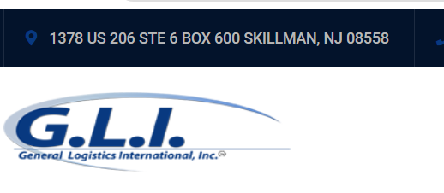

33 W Roosevelt RD, Suite N
Lombard, IL 60148

2)Can you please remove ? From main page?
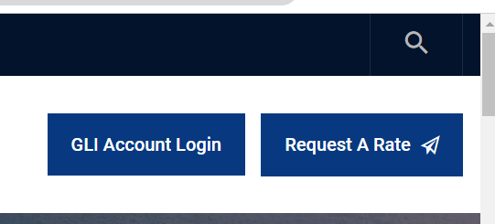

3)Replace words with below & remove that are in cross marks

- General Logistics International Inc. is a full-service, licensed freight forwarder and Ocean Transportation Intermediary (OTI). Whether you are a first-time importer/exporter or a Fortune 500 company, we offer tailored solutions to meet your unique needs.
- Our success is driven by our industry expertise and our unwavering commitment to supporting our clients' growth, utilizing tools and strategies developed through valuable customer feedback.
- Our advanced online platform empowers you to efficiently manage your shipments, offering features such as rate discovery, cargo booking, and bill of lading submissions—all from a single, customizable desktop solution.

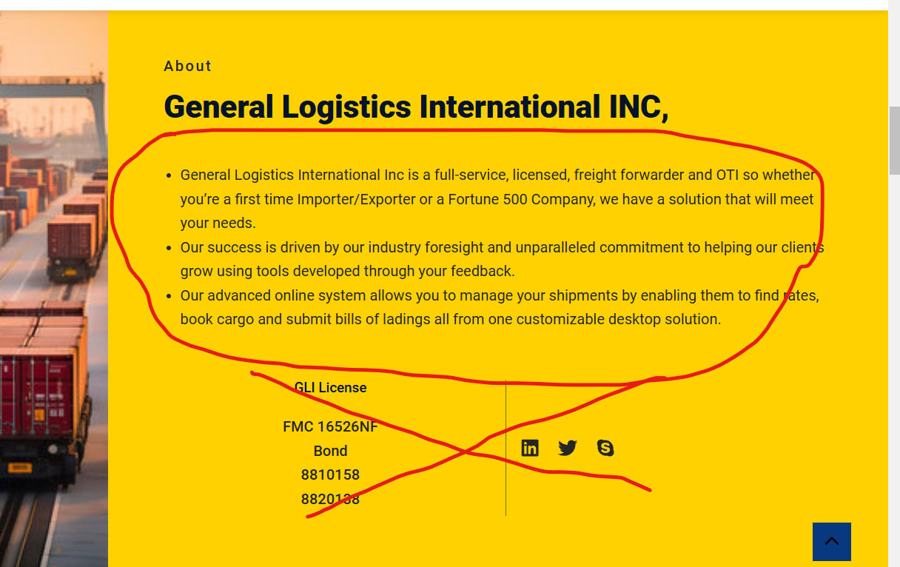

4) Correct buttons hyperlinks
For both

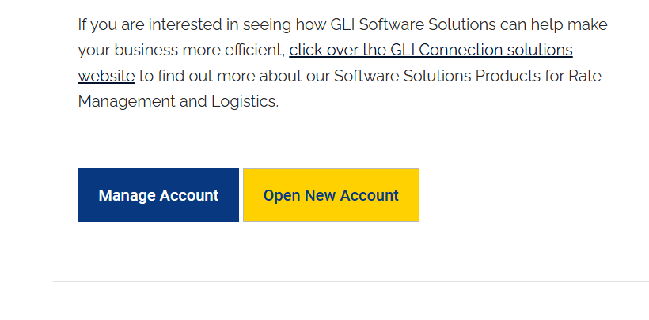
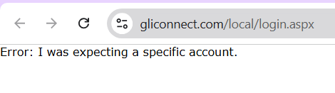
5) Remove word & Link’(View all Achievements )
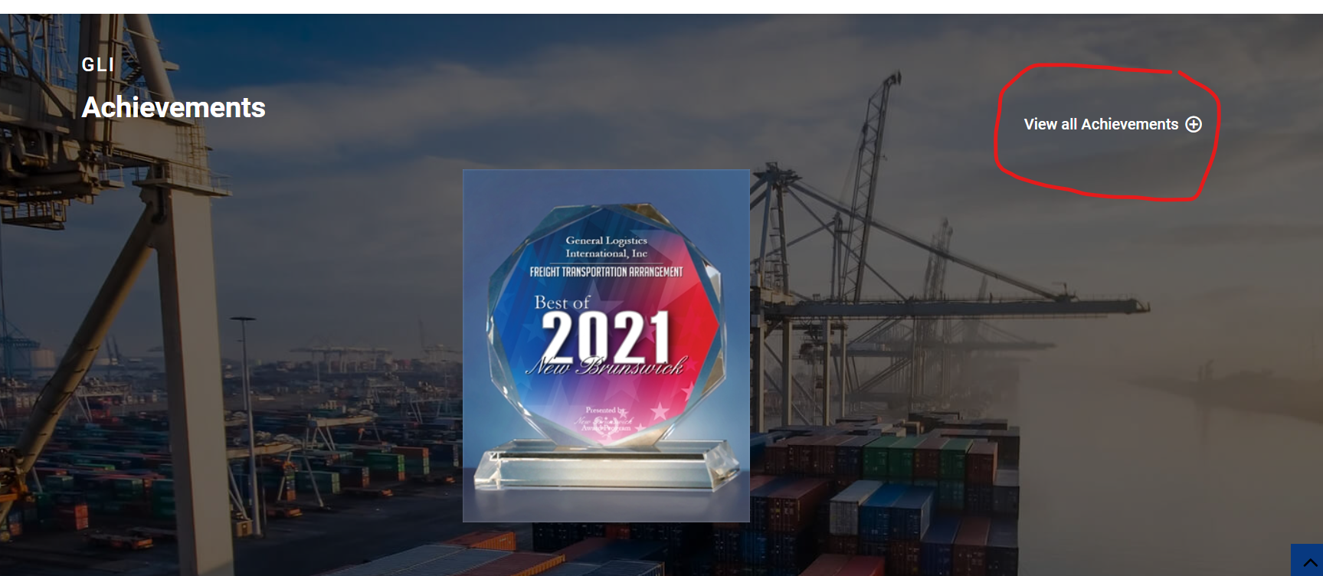
6) Remove image overlay hover effects, Giving wrong info & page link
(KEEP IMAGE ONLY)

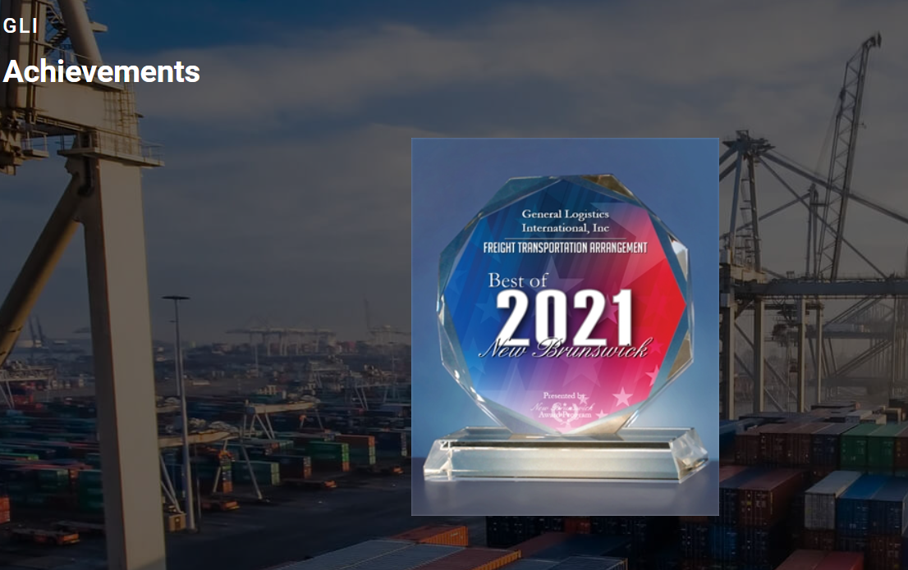

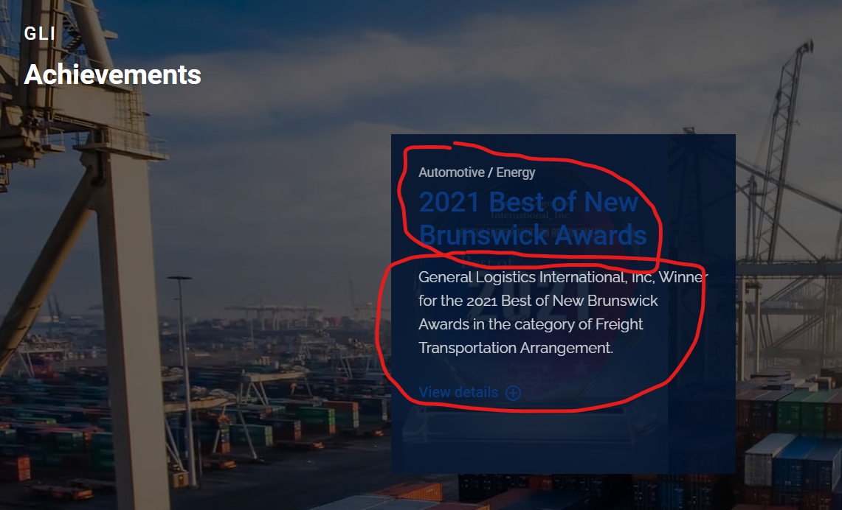

7)Correct office hrs & remove highlighted
Monday - Friday 9 am to 4pm

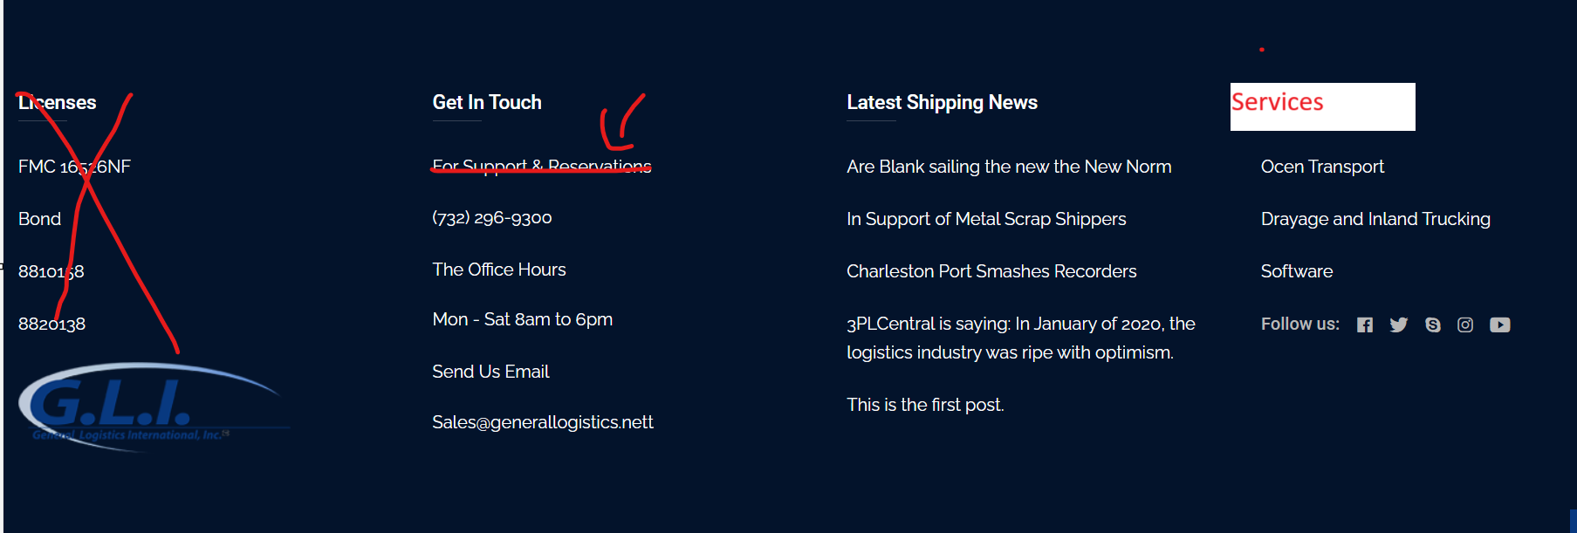

8) Correct the logo accordance to words
Ref
Ocean- Vessel logo
Drayage- Truck with container
Haz cargo

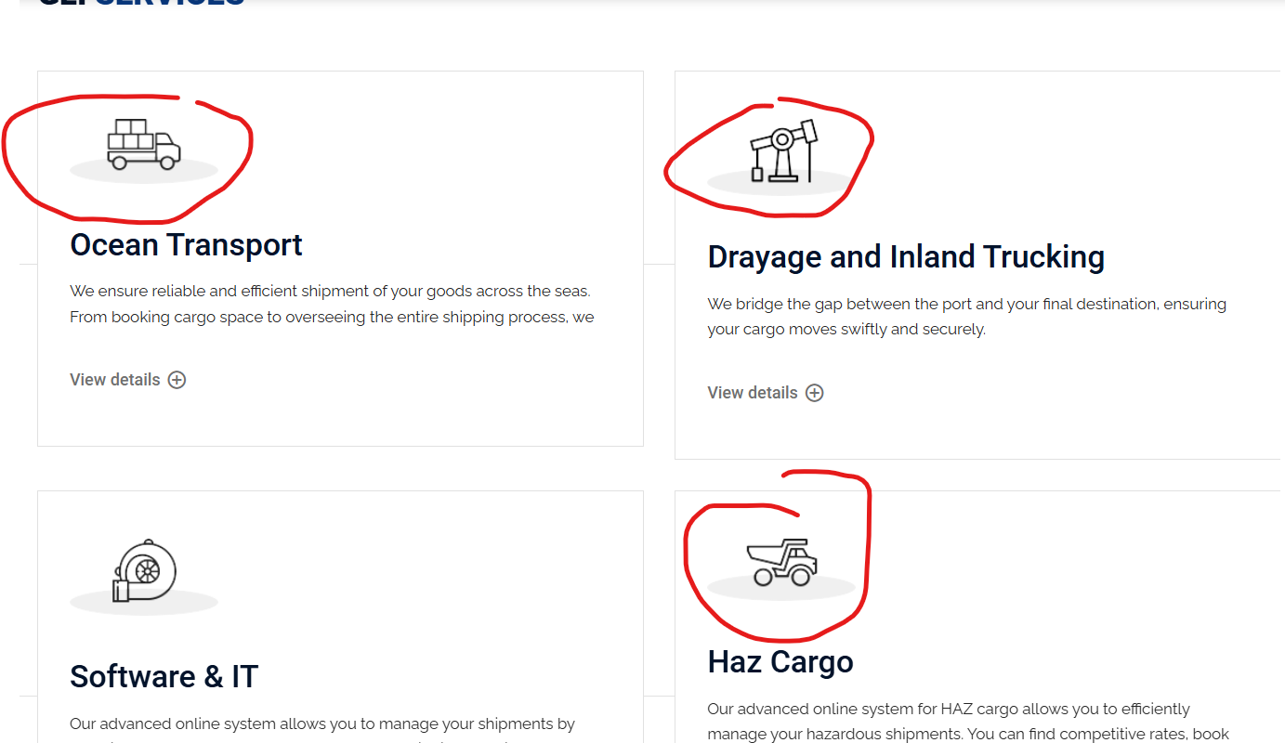

9) Replace words with below(Ocean Transport)
Since 1999, General Logistics International has been a trusted leader in providing comprehensive ocean transportation and freight forwarding services, expertly tailored to meet your global shipping needs. With over two decades of experience and a steadfast commitment to excellence, we deliver seamless solutions for transporting your goods across oceans, ensuring timely deliveries and cost-effective outcomes.

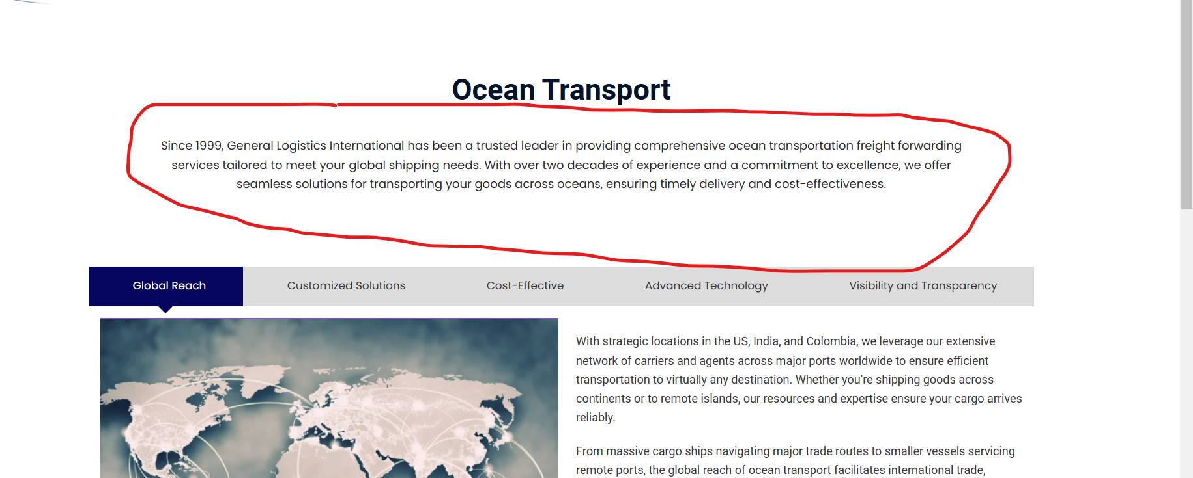

10) Replace words with below(Global Reach)

At General Logistics International, our global reach is supported by a robust network of strategic locations, trusted partners, and a vast array of carriers and agents across key ports worldwide. With operations in the US, India, and beyond, we ensure that your shipments are efficiently transported to any destination, no matter how remote or challenging.
Our global network enables us to provide comprehensive ocean freight solutions, seamlessly connecting continents, countries, and industries. Whether you're shipping large volumes across major trade routes or smaller loads to remote islands, we deliver reliable, timely, and cost-effective services.
Our extensive expertise in managing international logistics guarantees smooth, hassle-free transportation, giving you the confidence that your cargo is in capable hands every step of the way. With General Logistics International, your business can thrive in the global marketplace.

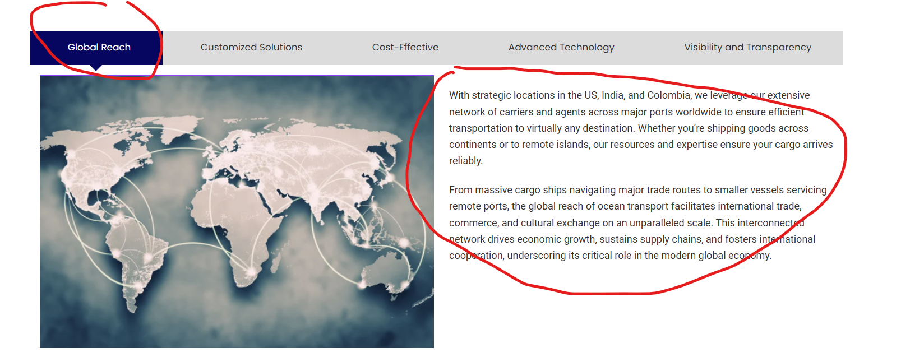
11) Replace words with below(Customized Solutions)

We understand that every shipment is unique, which is why we offer personalized solutions tailored to meet your specific requirements. Whether it's full-container loads (FCL), less-than-container loads (LCL), project cargo, or oversized shipments, we customize our services to accommodate the size, nature, and urgency of your cargo.
End-to-End Support
From initial booking to final delivery, our dedicated team of logistics professionals provides comprehensive support at every stage of the shipping process. We handle all aspects, including documentation, customs clearance, cargo tracking, and coordination with carriers, to ensure your shipment is transported smoothly and hassle-free. With General Logistics International, you can count on seamless, reliable service from start to finish.

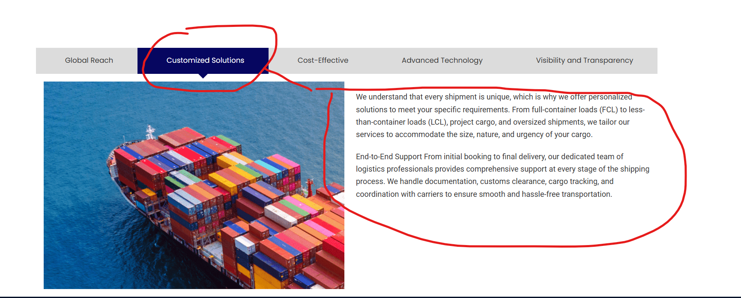

12) Replace words with below(Cost-Effective)
With our strong relationships with leading ocean carriers, we negotiate competitive rates to help you optimize your shipping costs without compromising on quality or reliability. Whether you're seeking the fastest transit time or the most economical option, we offer flexible solutions that align with both your budget and timeline.
While ocean transport may involve longer transit times, its lower operational costs make it an attractive choice for businesses looking to move goods over long distances. Overall, ocean transport remains a cost-effective and efficient solution for global trade.

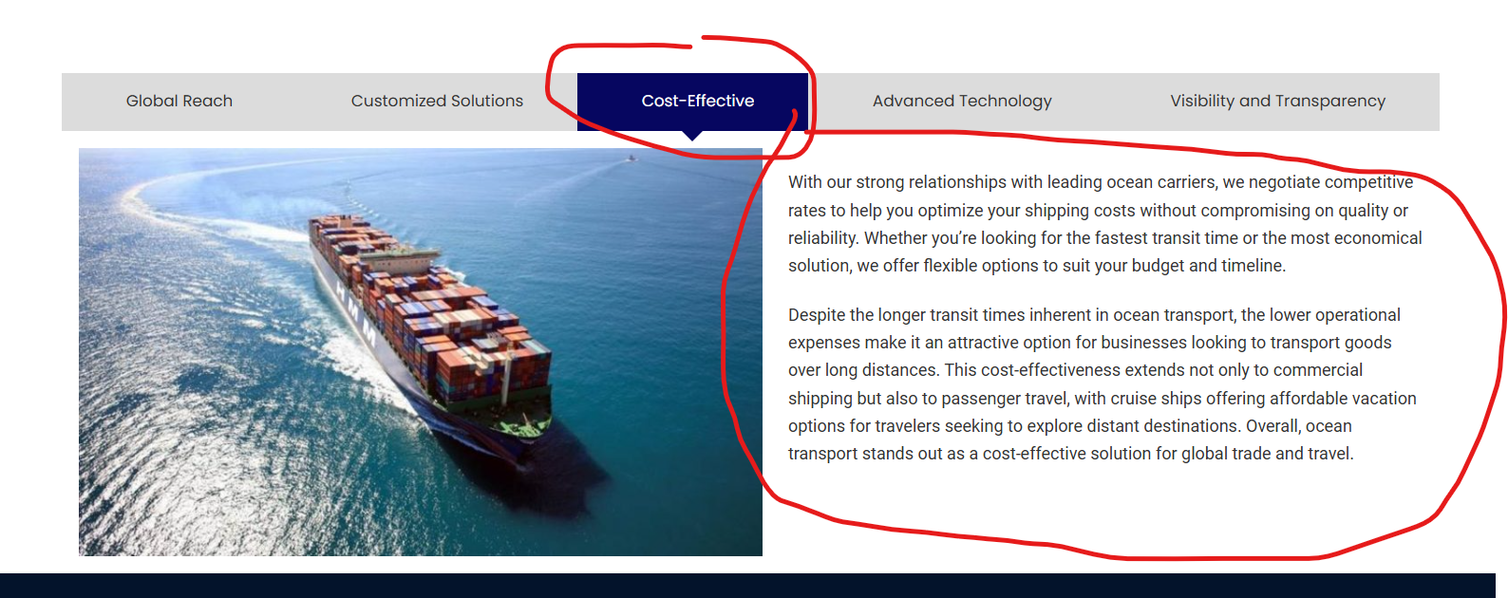

13)Remove Advanced Technology & Visibility and Transparency blocks

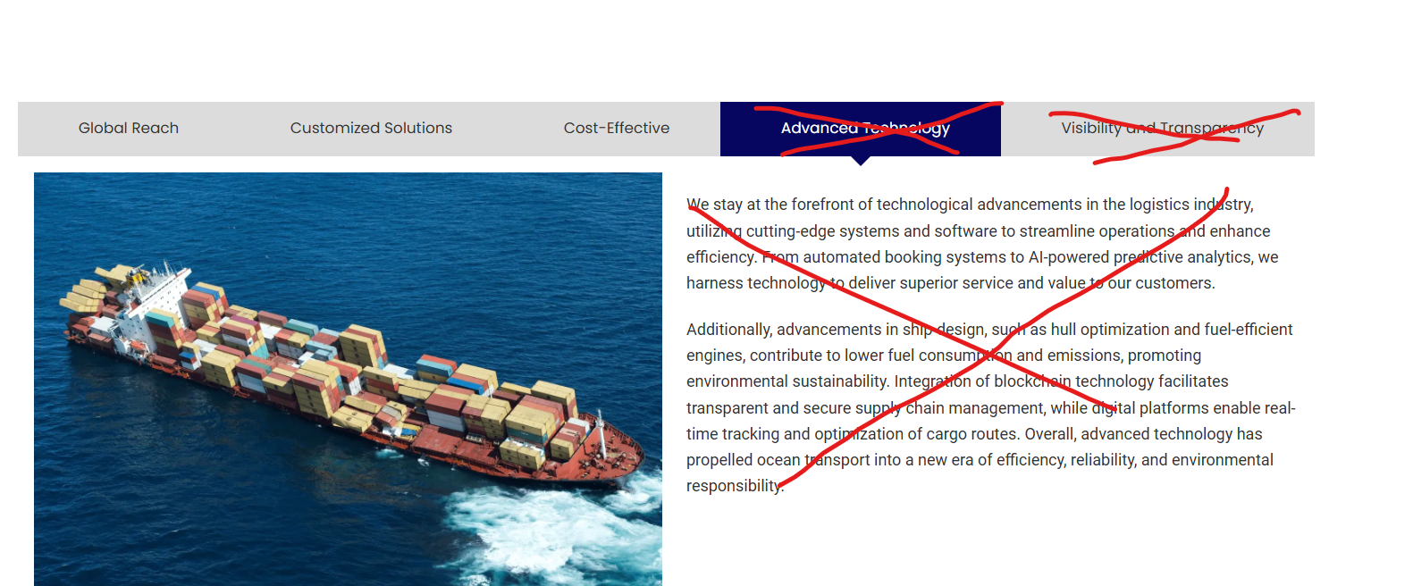

14) Replace words with below(Drayage and Inland Trucking)

We offer comprehensive drayage and inland trucking solutions designed to streamline your supply chain operations. Our services ensure the seamless movement of goods across various stages of transportation, from ports to rail yards and beyond

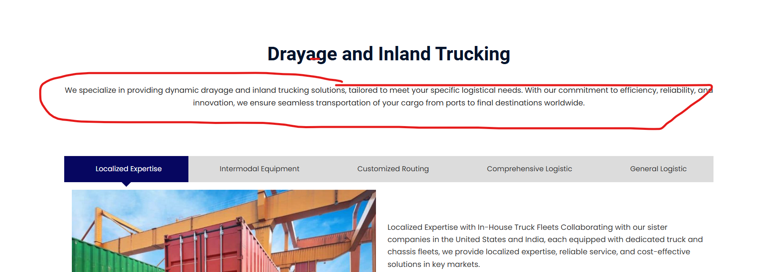

15) Replace words with below(Localized Expertise)
Drayage Services:
Our drayage services specialize in the short-distance transport of containers, moving cargo from loading warehouses to rail yards, ports, or distribution centers. We focus on efficiency and reliability, ensuring that your cargo is transported safely and promptly, facilitating the first and last mile of the supply chain.
Inland Trucking Services:
Our inland trucking solutions cover longer distances, providing cost-effective transportation for goods between rail terminals, ports, and final destinations. Whether moving freight across cities, states, or regions, we ensure timely and secure delivery, optimizing your logistics network for maximum performance.
With General Logistics International, you can count on flexible, tailored solutions for both drayage and inland trucking needs, ensuring your cargo is handled with the utmost care and delivered on schedule.

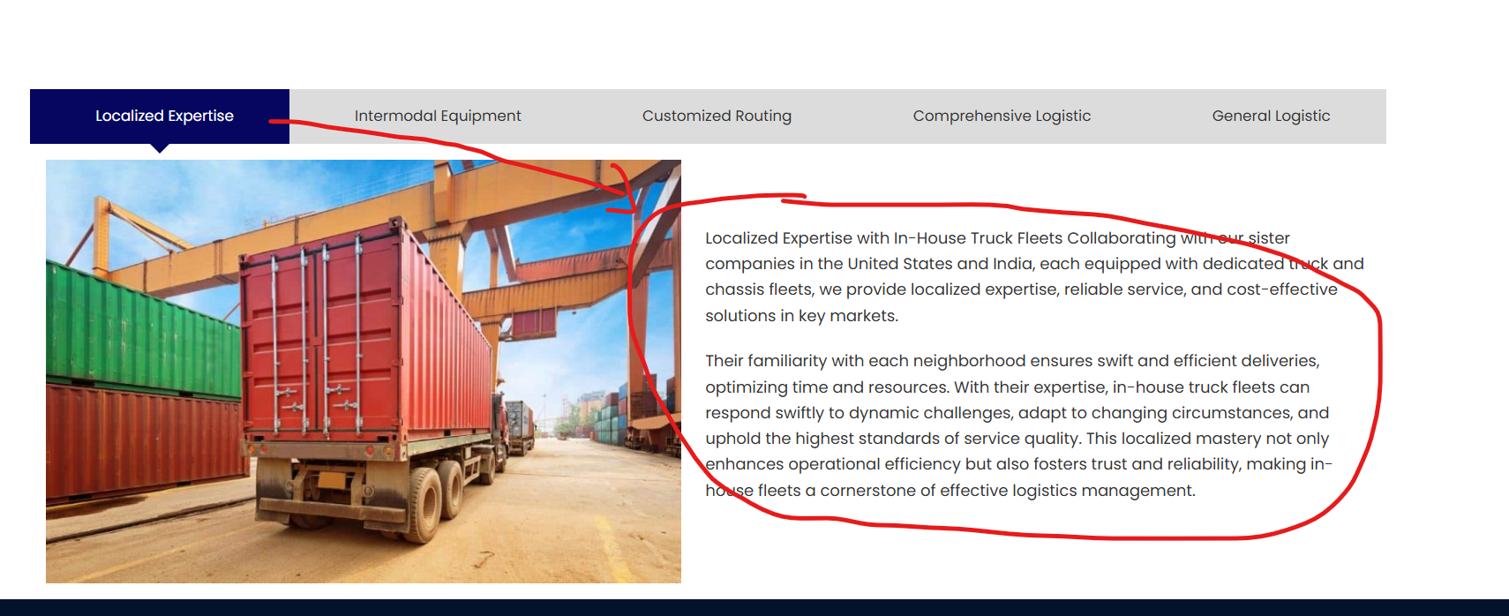

16) Remove All that are in Cross marked

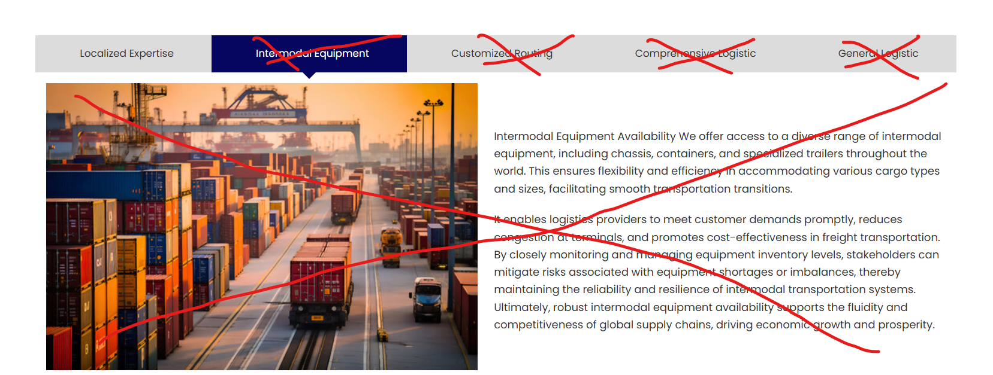

17) Keep 1 block only & 2-3 images (Haz Cargo)

Hazardous Cargo (Haz Cargo) Services
We specialize in the safe and compliant transportation of hazardous cargo (haz cargo), adhering to the highest industry standards and regulations. Our experienced team ensures the secure handling, transport, and delivery of dangerous goods, whether by road, rail, or sea.
Hazardous Cargo Handling:
We provide tailored solutions for the transportation of various hazardous materials, including flammable, corrosive, toxic, or reactive substances. Our team is fully trained and certified to manage the complexities of haz cargo, ensuring all safety protocols are followed and all regulatory requirements are met.
Compliance and Safety:
We prioritize safety and regulatory compliance, adhering to international guidelines, including those set by the Department of Transportation (DOT), International Maritime Dangerous Goods (IMDG), and the European Agreement Concerning the International Carriage of Dangerous Goods by Road (ADR). Our services ensure that hazardous materials are transported in secure packaging and are fully documented, minimizing risk during transit.
End-to-End Solutions:
From proper labeling and packaging to risk assessment and emergency response procedures, General Logistics International offers a complete solution for your haz cargo needs. We ensure that your shipments arrive at their destination safely, efficiently, and in full compliance with all legal and environmental requirements.
Partner with General Logistics International for reliable, expert handling of hazardous cargo, and trust us to keep your shipments secure while maintaining the highest standards of safety and compliance.

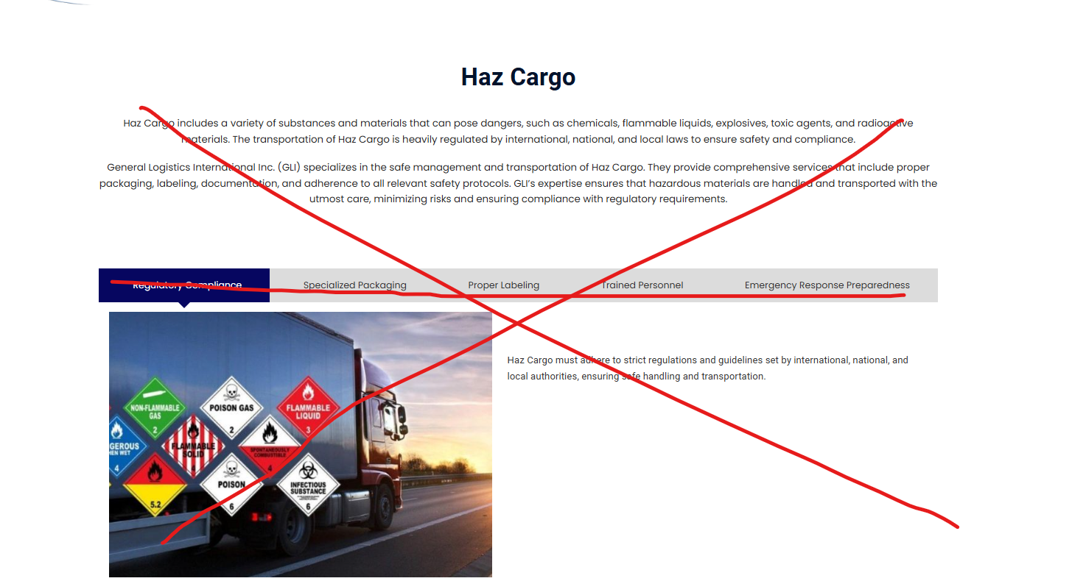

18) Add 4th option in services (Warehousing & Transloading)
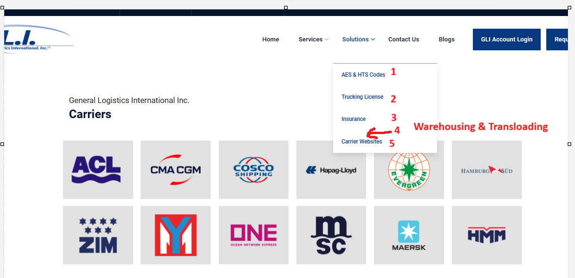

Warehousing & Transloading Services

we offer comprehensive warehousing and transloading services designed to optimize your supply chain and ensure efficient movement of goods. Whether you require short-term storage, long-term warehousing, or seamless transloading solutions, we provide reliable and cost-effective options tailored to your needs.
Warehousing Services:
Our state-of-the-art warehouses are equipped with advanced inventory management systems, ensuring your goods are stored safely, securely, and efficiently. We offer flexible storage solutions for a wide range of products, from raw materials to finished goods. With our strategic locations and expert team, we guarantee fast access to your inventory whenever you need it, improving your supply chain's agility and responsiveness.
Transloading Services:
Our transloading services involve the transfer of goods from one mode of transportation to another, ensuring a smooth transition between truck, rail, or containerized shipments. Whether your goods need to be transferred from a container to a truck for final delivery or between rail cars, we manage the entire process with precision, minimizing delays and reducing handling costs. We provide flexible and reliable solutions that streamline your logistics, ensuring your cargo is moved quickly and efficiently.
End-to-End Solutions:
From inventory storage and management to transloading and final delivery, General Logistics International offers end-to-end warehousing and transloading services that ensure your goods are handled with care and delivered on time. Our experienced team and advanced technology ensure maximum operational efficiency, helping you meet your logistical goals with ease.
Partner with General Logistics International for your warehousing and transloading needs, and experience streamlined, cost-effective solutions that enhance your supply chain’s performance.

19) https://generallogistics.net/trucking-license/ Show nothing
Please remove that option as we not providing trucking licence

